7COM1079-0901-2025 - Team Research and Development Project

Final report title: Statistical Analysis of Age at Award: A Comparison Between Nobel Laureates in Physics and Chemistry

Group ID: A64

Dataset number: ds021

Prepared by: Mughees Ahmed - 24086381
Muhammad Dawood Ahmad - 24065610
Talha Nawaz - 23086777
Aamir Shahzad - 24074308
Mohsin Shahzad - 24084628

University of Hertfordshire
Hatfield, 2025

Table of Contents

- Introduction
  - Problem statement and research motivation 3
  - The data set 3
  - Research question 3
  - Null hypothesis and alternative hypothesis (H0/H1) 3

- Background research 4
  - Research papers 4
  - Why RQ is of interest 4

- Visualisation 4
  - Appropriate plot for the RQ output of an R script and required supplementary graph/table 4
  - Useful information for the data understanding 6

- Analysis 6
  - Statistical test used to test the hypotheses and output 6
  - The null hypothesis is rejected /not rejected based on the p-value 6

- Evaluation – group’s experience at 7COM1079 6
  - What went well 6
  - Points for improvement 7
  - Group’s time management 7
  - Project’s overall judgement 7
  - Comment on GitHub log output 7

- Conclusions 7
  - Results explained. 7
  - Interpretation of the results 8
  - Reasons and/or implications for future work, limitations 8

- Reference list 8
Harvard (author, date) format. 8
- Appendices 8
- R code used for analysis and visualisation. 8
- GitHub log output. 10

1. Introduction

  - Problem statement and research motivation

The Nobel Prize is regarded as the highest form of scientific recognition, yet the age at which laureates receive this honour varies across disciplines. Prior research shows that the average age of the award has increased over time, with meaningful differences across fields such as physics, chemistry, and medicine (Jones, 2011). Understanding whether some disciplines systematically reward scientists earlier or later is important for discussions about career progression, talent development, and fairness in science policy. This study focuses on Physics and Chemistry because both represent core scientific fields with long Nobel traditions, allowing a clear comparison of award-age patterns between two closely related disciplines.

  - The data set

This study uses the “Nobel Prize by winner” dataset, which contains one record per laureate and includes information such as name, gender, birth details, country, and prize category. From the birth year and award year, each laureate’s age at the time of receiving the prize is calculated. For the analysis, the dataset is filtered to include only Physics and Chemistry laureates, resulting in a focused sample suitable for comparing age-at-award differences.

  - Research question

Is there a statistically significant difference in the mean age at which Nobel Prize laureates in Physics and Chemistry receive their awards?

  - Null hypothesis and alternative hypothesis (H0/H1)
To address the research question, hypotheses are stated about the population means of age at award for Physics and Chemistry laureates. Let Physics represent the mean age at award for Physics, and Chemistry represent the mean age at award for Chemistry.
Null hypothesis (H0): Physics = Chemistry. There is no difference in the average age at which laureates in Physics and Chemistry receive the Nobel Prize
Alternative hypothesis (H1): Physics ≠ Chemistry. The average award age differs between Physics and Chemistry.
A t-test, suitable for unequal variances, is used to evaluate these hypotheses at the 5% significance level.

- Background research
  - Research papers (at least 3 relevant to your topic / DS)

Several studies have examined when Nobel laureates produce their prize-winning work and the ages at which they receive the award. Bjørk (2019) analysed the Nobel Committee’s Advanced Information documents and showed that prize-winning contributions are often made in the mid-forties. The study also found systematic field differences, with physicists tending to complete major discoveries at younger ages than chemists. Chan (2022) investigated the timing of Nobel awards and reported that the overall mean age at receipt is about 55. However, discipline-level differences were observed, with physics laureates receiving the award at an average age of approximately 52.5 years compared with about 55.5 years for chemistry. Although these differences may be statistically modest, the study highlighted that they can be meaningful when considering career structures across scientific fields. Jones (2011) provided a broader perspective by reviewing long-term patterns in scientific creativity and documenting that peak ages of major contributions have shifted later over the twentieth century. He attributed this shift partly to increasing training requirements and expanding knowledge bases within scientific disciplines. Collectively, these studies show that award age reflects both disciplinary norms and historical change, providing strong motivation for examining whether Physics and Chemistry differ significantly in the age at which laureates receive the Nobel Prize.

  - Why RQ is of interest (research gap and future directions according to the literature)

Existing studies typically analyse all Nobel disciplines jointly or emphasise long-run trends, while giving comparatively less detailed attention to direct, up-to-date comparisons between closely related scientific fields such as Physics and Chemistry using publicly available laureate-level data. Our research question narrows this gap by testing, with a clear hypothesis-driven design, whether there is evidence of a mean-age difference between these two categories over the full historical record covered by the dataset. The findings can inform discussions about discipline-specific career trajectories, perceptions of “early” versus “late” recognition, and future work that might extend the analysis to time trends, gender differences, or other Nobel categories.

- Visualisation
  - Appropriate graphs for the RQ
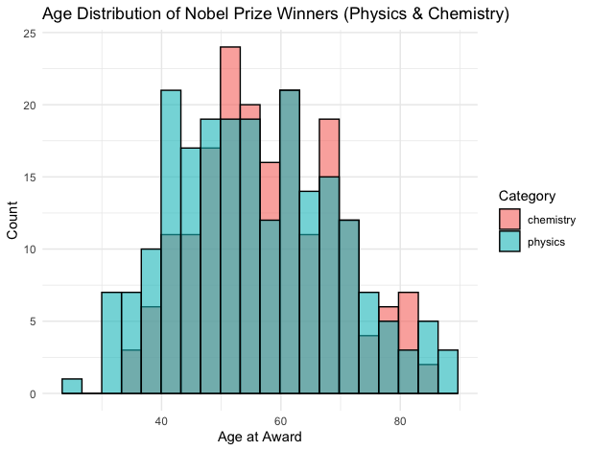
The histogram provides further insight into the underlying age distributions for the two categories. By overlaying the colours for Physics and Chemistry, the plot shows that both disciplines share a broadly similar shape, with the highest concentration of awards occurring between approximately 45 and 65 years of age. The Chemistry distribution appears slightly more right-shifted, supporting the observation that Chemistry laureates may receive recognition marginally later than Physics laureates. The tails of both distributions extend into older ages, but without major structural differences. This supplementary visualisation is valuable for verifying whether the assumptions of the t-test, particularly approximate normality and independent samples, are reasonable for this dataset.
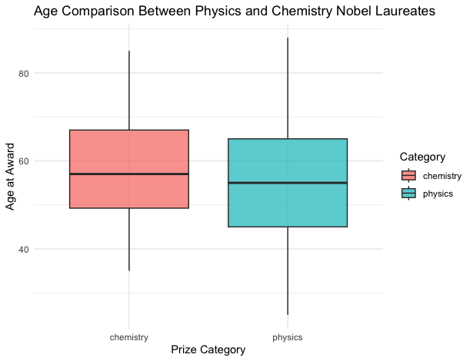

The boxplot provides a direct comparison of the distribution of age at award for Nobel laureates in Physics and Chemistry. This plot type is appropriate for a research question focused on differences in means because it visually summarises central tendency, spread, and potential outliers. Both boxes show broadly similar distributions, with Chemistry exhibiting a slightly higher median age than Physics. The interquartile ranges overlap substantially, suggesting that variability within each field is comparable and that the difference in typical ages may be relatively small. The plot therefore provides an initial descriptive indication that any difference in mean ages should be formally tested using a statistical method such as a t-test.

  - Useful information for the data understanding

Together, the boxplot and histogram provide an important descriptive foundation for the statistical analysis. They suggest that Physics and Chemistry laureates have broadly similar age profiles, with only modest differences that may or may not reach statistical significance. These plots guide expectations before modelling and ensure the subsequent hypothesis test is contextualised within observed data patterns.

- Analysis
  - Statistical test used to test the hypotheses and output

To evaluate whether the mean age at award differs between Physics and Chemistry laureates, a t-test was conducted. This test is appropriate because it compares the means of two independent groups and does not assume equal population variances, which is suitable for observational data of this kind. Using the derived variable age_at_award, the test produced a t-value of 1.8582 with approximately 405 degrees of freedom and a p-value of 0.06387. These results form the basis for assessing the hypotheses.

The null hypothesis is rejected /not rejected based on the p-value

Given a p-value of 0.06387, which is greater than the conventional 0.05 significance threshold, we do not reject the null hypothesis. This indicates that there is no statistically significant evidence to conclude that the mean age at which laureates receive the Nobel Prize differs between Physics and Chemistry. Although the descriptive analysis suggests Chemistry winners may be slightly older on average, this difference is not large enough to be considered statistically meaningful. Therefore, the data supports the interpretation that both fields recognise scientists at broadly similar stages in their careers, at least within the scope of this dataset.

- Evaluation – group’s experience at 7COM1079

  - What went well
The group collaborated effectively by dividing tasks based on individual strengths, improving efficiency and consistency in the analysis. Data preparation and coding progressed smoothly once responsibilities were clearly allocated, and regular discussions helped ensure that all members understood the research question and statistical approach. The visualisation and interpretation stages also benefited from shared review, allowing the group to refine plots and clarify analytical choices before finalising the report.

  - Points for improvement

One area for improvement relates to early-stage coordination. Initial uncertainties about dataset selection and task sequencing slowed progress, and clearer planning at the outset could have reduced this delay. Additionally, some members required extra support in understanding R syntax and statistical testing, suggesting that earlier skill-sharing sessions would have been beneficial. Strengthening communication channels and establishing more structured deadlines could further enhance group cohesion and reduce the need for last-minute adjustments.

  - Group’s time management

Time management improved throughout the project. After an initially slow start, the group adopted a more systematic workflow with periodic progress checks. This ensured that coding, visualisation, and writing tasks were completed on schedule and allowed enough time to review outputs before assembling the final report.

  - Project’s overall judgement

Overall, the project demonstrated strong teamwork and a solid application of statistical methods. The group produced a straightforward research question, generated appropriate visualisations, and applied a valid hypothesis test. The final output reflects consistent effort and improved technical competence, meeting the module’s analytical and collaborative expectations.

  - Note any changes to group since original allocation if applicable. Add new or amended GitHub Ids for new members

mugheesmad and ma24atx are both Mughees Ahmed accounts. There were some issues due to the office’s multiple accounts, and the commit got pushed from the office account.

  - Comment on the GitHub log output 50 words)
Three key commits were:
● " Add changes to difference of proportion analysis " – Initially, we were doing proportion so this commit is related to that. Later, we changed the research question
● "plot pic " - created box plot and histogram for clarity.
● "final report update" - produced statistical analysis using t-test.

- Conclusions
  - Results explained

The results show that although Chemistry laureates appear slightly older on average than Physics laureates, the difference is modest and statistically non-significant. Both visualisations and summary statistics reveal substantial overlap between the two distributions. The t-test confirms that any observed difference is likely due to natural variation rather than a systematic disciplinary pattern in award age.

  - Interpretation of the results

These findings suggest that the timing of Nobel recognition in Physics and Chemistry is broadly similar, indicating comparable career trajectories across the two fields. The absence of a significant difference implies that structural or cultural factors influencing recognition age may operate consistently across both disciplines. This reinforces the idea that scientific impact, rather than field-specific norms, primarily drives Nobel selection timing.

  - Reasons and/or implications for future work, limitations of your study

Future research could explore temporal trends, gender differences, or expansion to additional Nobel categories. The study is limited by missing birth data for some laureates and the assumption that award age fully reflects career timing. Broader datasets or longitudinal modelling would strengthen understanding of recognition patterns across scientific domains.

- Reference list

Jones, B.F., 2010. Age and great invention. The Review of Economics and Statistics, 92Simonton, D.K., 2004. Creativity in science: Chance, logic, genius, and zeitgeist. Cambridge University Press. (1), pp.1-14.
Chan, H.F., Mixon, F.G., Sarkar, J. and Torgler, B. (2022) ‘Recognition and longevity: An examination of award timing and lifespan in Nobel laureates’
Jones, B.F. and Weinberg, B.A. (2011) ‘Age dynamics in scientific creativity’, Proceedings of the National Academy of Sciences, 108(47), pp. 18910–18914

- Appendices
- R code used for analysis and visualisation
Analysis.R code with the appropriate statistics to test the hypotheses.

library(dplyr)
library(ggplot2)
library(readr)
library(lubridate)

# Import dataset
nobel <- read_csv("nobel_prize_by_winner.csv")

# Parse born and died dates (robust)
nobel <- nobel %>%
mutate(
born_date = suppressWarnings(parse_date_time(born, orders = "mdy")),
died_date = suppressWarnings(parse_date_time(died, orders = "mdy"))
)

# Clean dataset: keep Physics & Chemistry, valid birth dates, and create age at award
nobel_clean <- nobel %>%
filter(category %in% c("physics", "chemistry")) %>%
filter(!is.na(born_date)) %>%
mutate(
fullname = paste(firstname, surname),
age_at_award = year - year(born_date)
) %>%
select(fullname, category, age_at_award, year, gender, bornCountry)

# Histogram: Age distribution for Physics & Chemistry
ggplot(nobel_clean, aes(x = age_at_award, fill = category)) +
geom_histogram(color = "black", bins = 20, alpha = 0.6, position = "identity") +
labs(
title = "Age Distribution of Nobel Prize Winners (Physics & Chemistry)",
x = "Age at Award",
y = "Count",
fill = "Category"
) +
theme_minimal()

# Boxplot: Age comparison between Physics and Chemistry
ggplot(nobel_clean, aes(x = category, y = age_at_award, fill = category)) +
geom_boxplot(alpha = 0.7) +
labs(
title = "Age Comparison Between Physics and Chemistry Nobel Laureates",
x = "Prize Category",
y = "Age at Award",
fill = "Category"
) +
theme_minimal()

# Summary statistics by category
summary_by_category <- nobel_clean %>%
group_by(category) %>%
summarise(
count = n(),
mean_age = mean(age_at_award, na.rm = TRUE),
median_age = median(age_at_award, na.rm = TRUE),
sd_age = sd(age_at_award, na.rm = TRUE)
)
print(summary_by_category)

# t-test: compare ages between Physics and Chemistry
t_test_result <- t.test(
age_at_award ~ category,
data = nobel_clean,
alternative = "two.sided"
)
print(t_test_result)


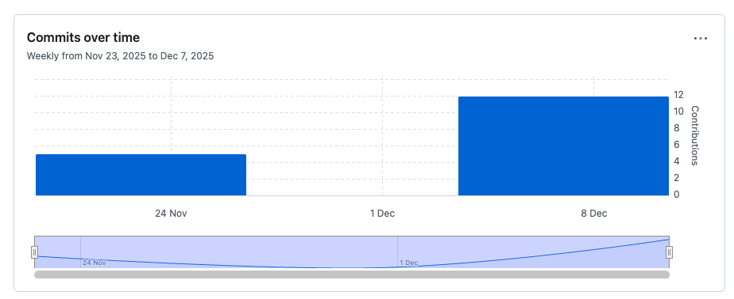
- GitHub log output.
https://github.com/ma24atx/7COM1079-0901-2025---Team-Research-and-Development-Project

